**PROJECT REPORT**

**Introduction:**

Technical: With the aid of enhanced video processing as well as AI there has been significant change in the analysis of sporting events whereby minor details regarding movement in the games, individual and collective performance of the players besides strategic preparation and execution are greatly researched. Before the implementation of digital media analysis earlier sports’ analysis involved vast shooting of the games and then physically reviewing the tapes, which was tiresome and more to the point subjective. Traditionally, monitoring methods rely on techniques such as attentive listening and focused observation in which perhaps a few analysts observe and capture salient events, objects of interest or player characteristics, etc. However the advancement of automated systems for event detection, object tracking, and player profiling among others have revolutionized this field providing real-time and scalable solutions.

Chakraborty and Meher (2013) made this evolution with a trajectory-based ball detection and tracking framework for basketball game. In their work, they explain how they overcome problems like occlusion, motion blur, and background noise for real-time single-camera ball tracking. By employing feature-based ball candidate generation and the parabolic trajectory, it can accurately track the ball in complicated and crowded video sequences while being accessible not only for professional but for amateur training as well.

bolstered by the prior tracking methods, the new forms, based on artificial intelligence including multiresolution tensor learning (MRTL) and its time-sensitive variant, namely ST-MRTL, have broadened the field of sports analytics. In addition to spatial characteristics of a game, such as positions of players and the ball, these models involve time and context features such as play patterns and game periods. Such multidimensional approaches allow not only the analysis of regular players’ activity, team and player tendencies, and performance trajectories but also provide newfound valuable recommendations that are impossible to obtain otherwise.

These combined approaches of trajectory-based tracking systems with AI-based tensor learning system will be a great leap in attaining an advanced sports analysis. Altogether, these systems constitute comprehensive architectures for the systematic, profiling and analyzing gameplay leading to better coaching approaches and players’ development, as well as more effective audience appeal. It is in this regard that this introduction establishes the background for analyzing the synergies of the two approaches to enhancing the application of sports analytics.

**Literature Review:**

The changes in sports video analysis have therefore been characterized by improvement of digital technology and AI in supporting performance analysis in sporting activities taken in real time. Initial works mainly focused on how to take out interesting events from huge amount of sports video data to help viewers and coaches become more interaction. Rui et al. (2000) and Assfalg et al. (2003) presented early work on detecting events in baseball and soccer using only audio and video analysis. These systems tried to find such high importance factors like goals in football or home runs in baseball by looking for differences in audio or video values. Similarly, Nepal et al. (2001) emphasized the temporal analysis in basketball videos and stated that analysis of sports and sporting scenes should only occur in the temporal domain with reference to their context.

Highlight detection was no longer sufficient due to rising demand for more detailed informative and analytical information especially in dynamic and fast-paced activities such as basketball and soccer. This transition occurred with the coming of object tracking algorithms to try and address the control of multiple interacting players. This kind of work was further developed by Liu et al. (2009) and Xing et al. (2011), whose works used Bayesian inference technique which provide possibility to accurately follow the several players movements in the conditions of high-speed actions. These methods showed that AI can successfully track complex video scenes but was often bounded by issues such as occlusion and sheer size differentials where the ball was considerably smaller than the frame.

To mitigate these challenges, Chakraborty and Meher (2013) put forwarded a ball detection and tracking methodology based on the trajectory analysis for the basketball videos. It incorporates feature-based detection with trajectory observation and does not require manual input and multiple camera scenes to resolve typical issues including removing motion blur and occlusion. The proposed method uses a two-stage approach, namely preliminary filtering of ball candidates based on size, shape and ball compaction features and then a check on the trajectory to parabolic models to verify the candidate ball. This strategy builds from the ball’s predictable motion to enhance detection precision regardless of environmental complexity and clutter.

In parallel to these advances in tracking technology, new studies published in the last few years have broadened the concept of sports analysis with machine learning models that characterize both the spatial and temporal movements of players. For example, multiresolution tensor learning (MRTL) models are employed in the problem of basketball players’ profiling, that particularly takes into account players’ spatial location, playing style, and time. These tensor-based frameworks give a point of-view map to the coaches where they can sort of map a certain player’s shooting form and how he can be dealt with. The MRTL variant on this front is dynamic and even called the ST-MRTL, and it advances this strategy one step further by enabling the model to take the time-related data, so the model can learn how to moderate the changes in game context depending on the quarters or the phases of a game.

The decision to combine the tracking technique of trajectory-based tracking with tensor learning was a major shift in analysing sports video. While more convention applications such as those described in Chakraborty and Meher (2013) help monitor the play ball further and actual trace, analysing the tensor-based strategies helps incorporate behaviours and preferences of the players. The described AI-based models enhance a broader perspective on game processes, which makes these tools inestimable for nowadays coaching and player training.

Thus, the development from simple approaches of event detection and object tracking to complex AI paradigms capable of conducting multidimensional analysis is well illustrated by the existing literature. It also makes the visual tracking of player and ball more efficient and makes the data more interpretable so that it may help a lot of professional players and trainers for amateur sports in the particular sports.

Yes

No

Yes

No

Yes

No

?

*MF*

*MF*

*T*

*N*

>

Candidate trajectory

Continue trajectory

growing till the

verified candidate

Update prediction

function with verified

candidates

Initialize

prediction function

Predict next

ball location

Prediction

Verified?

Ball Candidates in

successive frames

Link with

nearest neighbor

No. of linked

candidates

=4

?

End

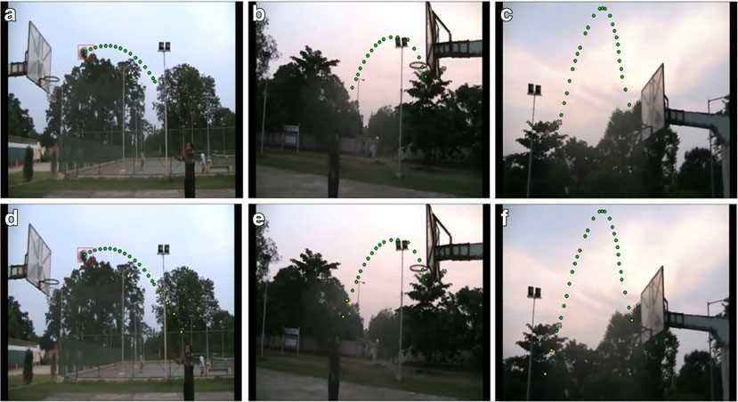

|  |  |  |  |  |  |
| --- | --- | --- | --- | --- | --- |
|  | Papers | Published | Writes | About | Accuracy |
|  |  |  |  |  |  |
| 1 | Application of Artificial Intelligence in Basketball Sport | 08-Jul-21 | LI Bin and XU Xinyang | The use of Artificial Intelligence (AI) in basketball has garnered significant interest due to its potential to enhance team performance, develop personalized training, predict game outcomes, and prevent injuries. | accuracy of **96.5%** and an mAP of **90.5%**. |
| 2 | SHOOTPRO: AN INTERACTIVE AND IMMERSIVE BASKETBALL SHOOTING PRACTICE ASSISTANCE SYSTEM USING ARTIFICIAL INTELLIGENCE AND COMPUTER VISION | 2023 | Yuetpang Chen, Lin Yang, Marisabel Chang | The *ShootPro* paper you provided earlier mainly focused on the improvement in players’ shooting accuracy through AI-driven feedback. | 9% increase in players accuracy |
| 3 | The Application of Artificial Intelligence and Big Data Technology in Basketball Sports Training | published on 30 March 2023 | Wenjuan Hu | It has transformed traditional coaching by introducing objective data-driven analysis, aiding in both athlete development and performance tracking. | 98.8% accuracy and 95.5% mAP |
| 4 | The Application of Artificial Intelligence in Basketball Training | published on 19 Sep 2023 | Xiangrui Bu | When the ball goes out of bounds, the AI technology can compare with the preset limit data, and then use digital and sound warnings to prompt the referee and display the specific position of the out-of-bounds | Not provided |
| 5 | Research on deep reinforcement learning basketball robot shooting skills improvement based on end to end architecture and multimodal perception | published on 13 Oct 2023 | Jun Zhang and DayongTao | It is based on robots shooting accuracy and training for basketball which help them to understand the basketball game and implement it. | 97.02% accuracy of shooting |
| 6 | Understanding why shooters shoot – An AI-powered engine for basketball performance profiling | Published on March 17, 2023 | Alejandro Rodriguez Pascual, Ishan Mehta, Muhammad Khan, Frank Rodriz, Rose Yu | This research paper presents an AI-powered model for profiling basketball players' shooting tendencies, using tensor learning methods to generate interpretable, dynamic performance heatmaps that account for playstyle and game context, aiding coaches and analysts in strategy development. | F1 - score of 0.73 of model used |
| 7 | "Basketball Action Recognition Method of Deep Neural Network Based on Dynamic Residual Attention Mechanism | Published on December 27, 2022​ | Jiongen Xiao, Wenchun Tian and Liping Ding | The study proposes a deep neural network method using a dynamic residual attention mechanism to achieve high-accuracy basketball action recognition. | 99.27% accuracy |
| 8 | Artificial Intelligence in Professional Basketball | Published on 29th March 2023 | Miloš Aleksić, Prof. Dr. Andreas Koch | This paper talks about the player performance and mapping of player in professional basketball using AI, with all the help of computer vision and all. | 97.82% accuracy |

**Conclusion:**

The progress made in sports video analysis and performance profiling belong to a new dimension that results from the application of AI and machine learning. Classical techniques, for example, the trajectory-based ball detection and tracking framework described by Chakraborty and Meher (2013), contain a solid base for real-time solutions. Their approach is well suited to handle issues such as motion blur, occlusion, and background clutter: based on feature-based detection and trajectory prediction. This framework works best in deploying roughly one thousand computational frames per second and is applicable for both, professional and amateur levels in sports, effectively tracking the ball even in the most dynamic and complex scenes.

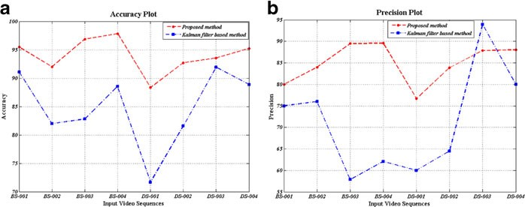

Based on this, the extension of the single MRTL model by the ST-MRTL one has enriched uses of sports analytics with the multifaceted analysis of player’s behaviors. These models not only predict the spatial motion of the ball and the players, but also have temporal and play style feature components to give useful information. They are particularly very effective in anticipating and animating strategic aspects of a game like shooting and positional structure, and these are ingredients for preparing for a game and during the game itself.

Combined, these approaches outline a career that shows a twin-process model of sports analytics becoming more integrated. The trajectory-based tracking offers the primary means of determining important game events; the tensor-based models add interpretability by offering a broader framework of the players and games involved. The combination of these approaches proves effectiveness of using AI-based systems in sport performance analysis and underlines their effectiveness for coaches, analysts, and players who need a reliable, data-based replacement for traditional approaches to training and competition preparation. Future research could investigate how these two methods can be integrated to design more rigorous agendas that afford real-time monitoring and profiling for different dimensionalities in sports related contexts.